*Ulises Almaguer Guzmán -* A01209070

*Topiltzin Hernández Mares* - A01703266

*Luis Jesús Morales Juárez* - A01703455

*Carlos Alfonso Sánchez Rosales* - A01703280

***Second Advance Final Project: OverFlow***

***Analysis of the user’s tasks***

Taking into account the type of project in which we are working, as well as the fact that nowadays, in order to be able to carry out an in-depth investigation, it is necessary to reach a large number of people, our team firmly believes that the best option to be able to obtain the most information about the user, is through surveys.

We consider that online surveys are the best option since they even go according to the ideology that we try to make known. Our project "OverFlow", tries to be an innovative proposal of study in the actuality, reason why this innovation must be carried out in all the levels of the project, from the surveys realized to the users, until the design of the application.

It would be counterproductive if our project shows a highly innovative ideology, but that our methods of searching and obtaining user information are obsolete. We believe that it is necessary to evolve from old-school methods of data collection (such as interviews or paper surveys) to methods that are much more effective and reach a greater number of people.

On the other hand, and according to Ruth Alonso, online surveys are one of the best tools for gathering information, since they present a wide variety of advantages over other conventional methods (Alonso, 2012):

* Speed: due to the fact that there are no intermediaries, the answers are received by the interviewer, almost at the moment in which the respondent presses send (Alonso, 2012).
* Possibility of including interactive elements: this allows the interviewer to create a survey that is much more friendly and understandable by the user, so it is possible to make the user feel more comfortable when answering the various questions (Alonso, 2012).
* Anonymity: another, if not the greatest advantage is the fact that the answers are sent without added personal information, so that everything is extremely confidential (Alonso, 2012).
* Greater number of answers with greater scope: it is possible to generate a survey with questions with rich informative content, which can reach a large number of people (Alonso, 2012).
* It is possible to reach target users that are not normally accessed (Alonso, 2012).

**In order to access the online survey use (were done in Google Forms):**

**ID:** [**A01209070@itesm.mx**](mailto:A01209070@itesm.mx)

**Pasword: Elcapi=0902**

In order to be able to obtain more informative answers from the users, two types of surveys were carried out.

The first type of survey deals with the design and simplicity of the page, with this we mean that in this survey the user is asked what type of web design is preferred, what type of navigation he prefers, what are the web platforms that uses more frequently, what features the user of a web page values more, what features make the user feel comfortable, as well as certain characteristics that users prefer when interacting with an interactive system.

The second type of survey that was carried out had as its central theme the project which is currently being carried out. For example, the user was asked what he would expect from an online learning platform, what features would he expect this service to have, what amenities he would like that platform to handle, as well as how much depth he would expect from the content he finds in such platform.

Having said the type of online surveys that were carried out, we got the next results:

Within the first online survey that we did, we found the next results: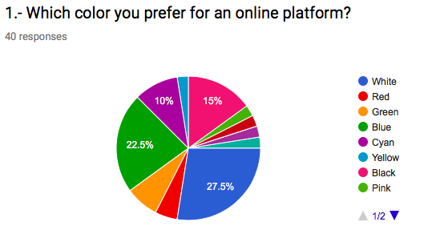

From the first question we can get that the colors preferred by the users are white, as well as blue, black and cyan.

So, our interface would try to implement such colors as far as possible.

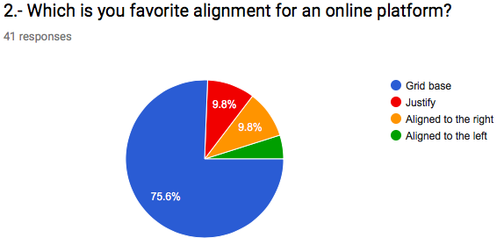

Due to the fact that most of the people prefer to have a grid base alignment, our online platform will implement such alignment.

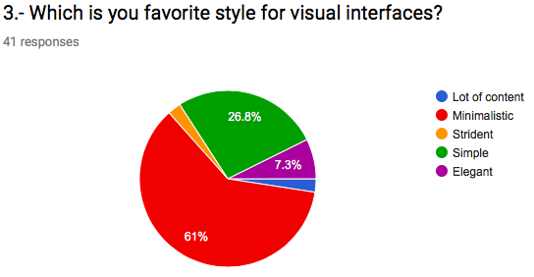As expected, many people decided that the best style for our visual interface is to keep it simple and clean; in other words, the interface must be minimalist and neat.

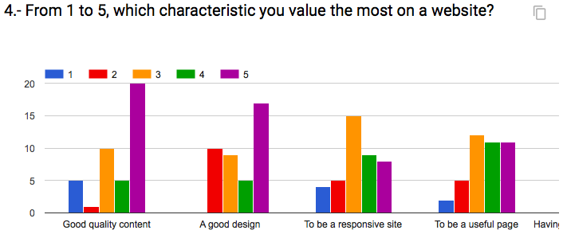

In order to have a well-designed platform, it was asked to the target audience which the most valued characteristic of a website was.

They said that the most important aspect is having good quality content, followed by having a good design, a responsive site.

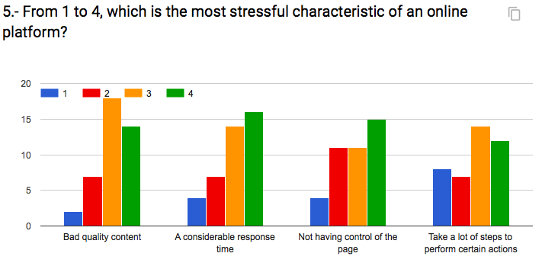

The most stressful characteristic of the user is taking a lot of steps to perform certain activities, followed by not having control of the page, a considerable time of response and bad quality content.

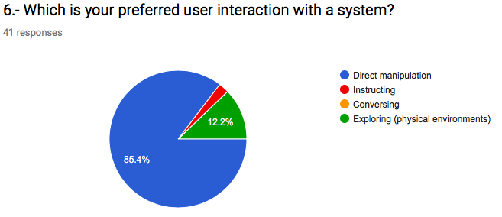

The preferred form of interaction is through direct manipulation, so our interactive application will implement such type of interaction.

On the other hand, in our second online survey regarding the content in the platform, we obtained the next results:

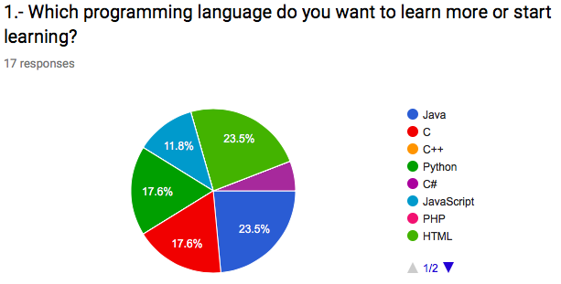

This question helped us to know which is the most important content for the users, so our interactive system will focus in offering tutorials on the most demanded programming languages.

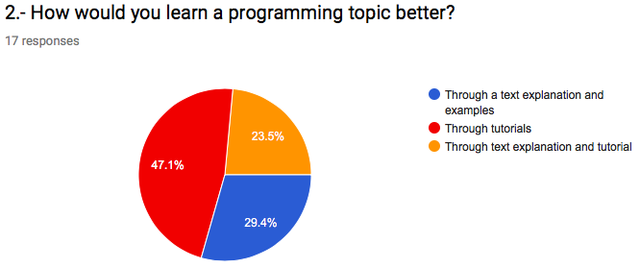

This question helps us to know how the user will be more likely to get the content on how to learn.

It is possible to see that the target users want video tutorials as well a text explanation.

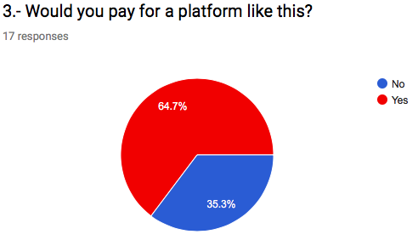

Although many of our target user may at a certain level pay for what is provided in the platform, we believe that it must be open-source.

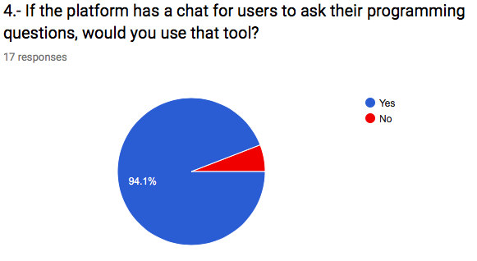

It is important to mention that our target users may value the characteristic of having an online chat, where they can ask their programming concerns about the topic, nevertheless, this feature is not yet decided to be implemented.

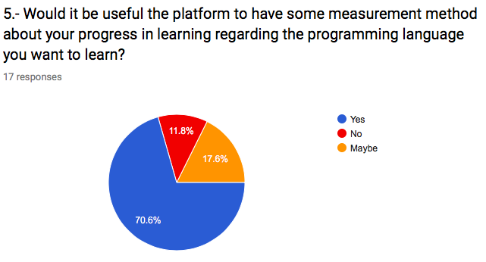

Another important characteristic that most of the user will value, is the fact that the application can have a way of measuring their progress in the learning of a certain programming language. Nevertheless, this is a feature that is not yet decided to be implemented.

With all the information gathered, our proposal consists on designing an open-source platform where the users may be able to have good quality content regarding the most demanded programing languages. The system will provide as much tutorials and information about the different programing topics.

The interface that will be implemented will be a minimalistic one, will be simple and useful, trying to implement the most valued characteristic that the users stipulated, while at the same time, the not desired characteristics will be reduced to their minimum expression.

***Prototype design***

***Information design***

We truly believe that the informational design that our application must have is the one that best fits the target user, by that we mean that in order to choose the best information design possible, it is necessary to really get to know out target audience, since that point, and based on the complexity of the information handled on our website, it is possible to choose the best information design.

Based on our previous online survey that we did, we found out that the main people that were interested in the development of “Overflow” were young people, with an approximate age from 15 to 25 years old, who were mainly students of information technology careers, designers, young people interested in web design that want to learn new development skills to create better web sites.

On the other hand, from the surveys we obtained that the people interested in this project think in a really logical and critical way, in the same way, they are familiar with the different basic programming concepts such as variables, constants, functions, methods, control structures. So, from that, we can say that our target audience is not such novice but instead, they have such background knowledge of what to expect.

So, in order to decide the best information design, it is possible to summarize, that out target audience are young people interested in topic of programming design and may have some background knowledge of the different topics.

So, taking that into consideration, we believe that due to the fact that our target audience is not such a novice audience, we can create an application that may be a more complex than a sequential or linear structure.

We consider that the best information structure for the application is a combination of the different structures, this has the purpose of creating a better structural organization of the information that is handled, while it allows the user have a fluid navigation in the application, in such a way that the user can easily find what he is looking for, but at the same time motivating the sense of searching and curiosity to explore new topics.

Having said that, it is possible to said that the information structure that is going to have is a star structure, with a combination of a hierarchical structure.

There is going to be a main web page from where you can be able to select which course you are interested in; once you click on such course, you are redirected to a new interface, where according to the topic you want to learn, a new dependency line from such topic is presented to the user.

***Star Structure.***

Home

(Landing Page)

Courses

Paths

Detail Course

Gallery

Contact

1.- Home: This page will be the first site to be visited by our students when they enter to our platform. With a clean banner with promotions and news, we plan our visitors get a good first view about our site. In this page, there will be a linear menu, with all the links to the other sites of out platform. All the other sections will be based in the same interface of the landing page, so the users won’t confuse.

2.- Courses: In this part of the site, we’ll show all the available courses in our platform with a minimum description for the viewers. If the users want to know more about the course they like, they will be able to click in a “More info” button and they’ll go to another page, Course Detail.

3.- Detail Course: When a user wants to know more information about a course, they will go to this part of the platform, where we will include full description of the course, a representative image of the content and all the summary. The user will be able to watch a demo, so they can know what they are going to download.

4.- Paths: As we are going to have many courses about different topics, we will divide them by paths. In this section the users will choose a path, so they can get to the courses they want faster. When a user finishes a path, they will get a little price.

5.- Gallery: In this section will be available pictures of our team, how we work and how we developed the platform.

6.- Contact: Here we’ll provide our actual information contact, like Facebook, Twitter, Instagram, Github and maybe a phone number. We’ll do this because we want to get feedback of our work and how we can improve it. Also, we want to get contacted by possible partners to develop new platforms and keep growing us.

***Interaction design***

In order to achieve a better user interaction, it is necessary to know the target users to which our product is directed, after the various investigations and online surveys, it was found that our target audience are mostly students between 15 and 25 years; as well as people who are strongly interested in the development of web pages and in applications of other programming languages.

In the same way, thanks to the various researches, it was found that those interested in this application are mainly people who have a certain degree of knowledge about programming issues, that is, they are familiar with topics related to programming as concepts of such as variables, constants, functions, methods, control structures.

Keeping in mind all what has been mentioned, it is possible to affirm that the type of interaction that the user will have with the system should not be overly simple, since the target public has some degree of experience about computer issues.

On the other hand, the type of interaction that the user must have with the system must be an interaction that promotes curiosity to introduce young users to the world of curiosity and knowledge (in fact, this is one of the goals of the development of this interactive system); however, it must also promote a minimalist interaction to avoid losing the user's attention quickly.

So, having said that, it is possible to say that our interaction style is going to be simple, there will be no necessity for any instructions, the interaction of the user with the platform will be direct manipulation. So, by making this platform by direct manipulation, we can achieve several things, first, it will help to the development of curiosity and abilities such as self-study, decision making, among others; on the other hand, it will help to keep the platform clean and minimalistic, in a way that you can find what you need.

The interface; which will be the main way of interaction between the user and the interactive system, will be clean, according to the latest trends of web design. The design philosophy we will use is going to be **Google’s Material Design**. This way, we can save time in the design in order to make a better functionality of out project. As has been mentioned several times above, the interface that is going to be presented tends to be minimalist, so that the information is easy to search and find.

It is possible to say that the generated user experience and interaction will be clean, minimalistic, in fact the user may know how to interact with the system without any new knowledge, it will be intuitive and simple to work will; it will just work. With Material Design the UX will be more comfortable because almost all the regular users we expect to use our platform are familiarized with this kind of designs.

The students are going to interact with our system in many forms. There will be a global Navigation bar, with links to all the important parts of the platform (star structure). Images, buttons and links will be available too, these will help to attract the user attention without overloading the user memory with too much colors of figures.

***Visual design***

As already mentioned above, it is possible to say that the visual aspect of the web page will be very minimalist, in such a way that motivates the search for information and curiosity, however it will not hinder the search for information to the user.

In order to achieve what was previously mentioned, it is really important to take into consideration the style, the organization, the color synchrony and the object arrangement of the objects. In the same way, it must go according to the information and interaction design.

* *Color synchrony*

The color palette that will be used in our project is the one that provide (shown) in the picture.

The reason why we chose those colors is because according to different studies that have been made in this sector, those colors are the ones that encourage and promote learning.

The blue color represents motivations, quality needed by the students in order to initialize their lives in the world of curiosity and self-study (Universa, 2017).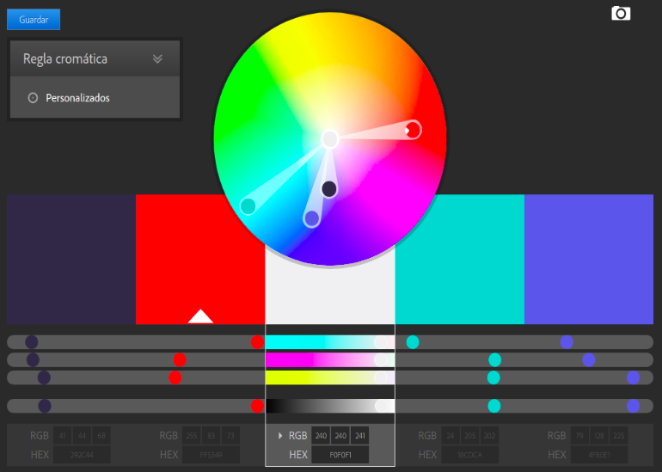

The yellow color is used to symbolize quality and interest (Universa, 2017).

On the other hand, orange and dark blue are used to symbolize productivity, positive attitude and creativity (Universa, 2017).

In fact, it can be seen that all the skills and characteristics that represent the colors that are going to be used, are in fact the ones that the platform is trying to spread and inculcate in the students (Universa, 2017).

* *Fonts*

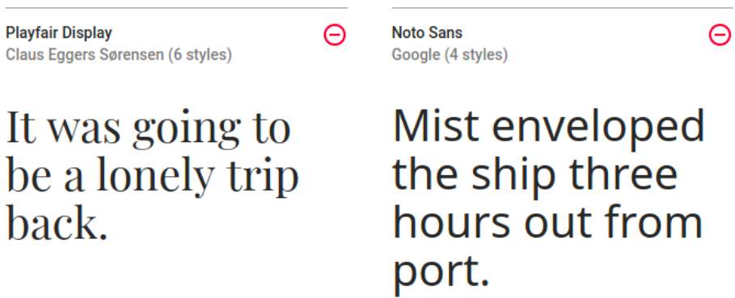This kind of fonts are, currently, very well accepted by the users, because help to keep clean the interface and are very light. Maybe in future, we’ll change this fonts for others with more quality.

The main reason why that type of font was chosen is because of its simplicity, it is necessary that the page is easy to read and understand. In other words, it is utilitarian and pragmatic, concepts that the Overflow project tries to transmit.

* *Alignment type*

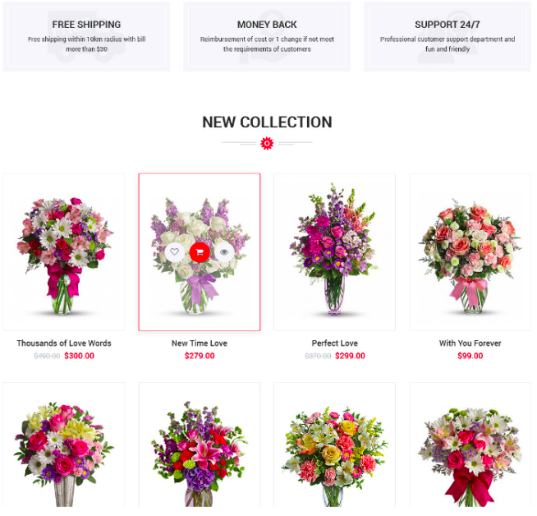As you can see in the image, the platform will be gird based. This “new” display type is used by almost all the online platforms, like CódigoFacilito.com, PluralSight.com, Medium.com, etc.

We’ll try to keep this alignment type, but the design of the cards of our system is going to be very different from the ones in the picture, ours will be Material Design based; with more shadows, different z-indexes and flat images.

The main reason why this type of alignment was chosen is the same as mentioned in the font aspect, the main intention is to maintain a clean graphic interface that is pleasant to the taste, that is utilitarian and pragmatic, easy to understand and to see; in such a way that facilitates and optimizes the search of information (Borgen, 2017).

* *Arrangement of the visual elements*

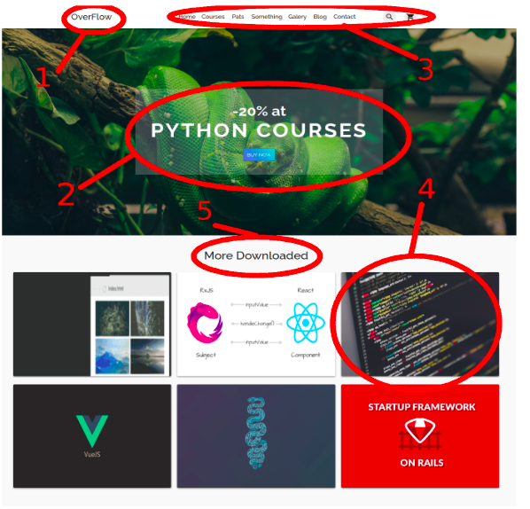

1.- Logo: According to Ángel Gonzalez in his article about web design (Gonzalez, 2012), what people sees first, is the upper left corner of the sites, so we want people to see first our name.

2.- The offers and promos: To keep the interest of the users, we’ll use a carousel banner as a header of the site. This way we can keep the attention of the visitors in what is important.

3.- The menu: As Ángel Gonzales mentioned in his article, people scans the sites like an “F”, so it’s important people don’t loses the attention of the content of the site. The menu will be designed with a linear structure in order that the users won’t confuse with more complex interface. This component will be separated in other 3 small menus. The first will provide a fast link to the home. The second all the links to the other parts of the site, so they can be reached easily. And the third will have buttons with spetian functions, like open a search bar and other to open the shopping cart.

4.- The Courses: According with what we were saying above, the alignment type of the site will be a Grid System. We’ll use the image grid system to keep a clean looking interface.

5.- Titles: This will help the users to don’t lose any information of the site

All the texts we’ll have in the platform will be simple and clear. This is in order to keep the simplicity that we try to express with the minimalist design. This also will apply for all the buttons, with bright colors and some shadows, to keep the same principles of our design.

All the images will be super minimalist, so the users can focus more in the content than in other things like pictures, buttons and fonts.

***Analysis of the implementation of the interaction design principles in the designed system components***

* *Strive to be consistent*

In order to achieve the implementation of this first golden rule, it has been decided to have a minimalist design throughout the graphic interface of this interactive system.

For this, the type of font chosen, as well as the type of alignment that was decided to use, are in accordance with the idea of ​​having a minimalist interface that is simple to use, in other words, they are coherent.

On the other hand, the colors used in the platform are colors that motivate the study and the search for information; in fact, they are colors that promote self-study and curiosity; values ​​and skills that are in accordance with our philosophy that we try to create in our target audience.

In the same way, with respect to the way of interaction between the user and the system, the only form of interaction that will be used is through is direct manipulation, which will be consistent throughout the platform; in the same way, thanks to having a direct manipulation interaction, we will give the user full control over what happens in the system.

Finally, to achieve the implementation of the first golden rule, similar terminology will be used for the different sections that the application has; in fact, the same design format will be used for the buttons, in such a way that the users can quickly distinguish what they are, the same font and color will be used for the titles and the same will happen with the text.

In order to maintain the same design throughout the application, in such a way that it is constant, **Google’s Material Design** will be used, in this way, the interface that is going to be presented will be minimalist, so that the information is easy to search and find.

* *Universal usability*

In order to achieve compliance with the second golden rule, the development team has decided that the system in development should be able to be used by the general public, in fact, even though the application is focused on our target audience with an age of between 15 to 25 and with a certain degree of interest in the subject of programming; the application can also be used by newcomers in the use of a computer, as well as beginners in areas related to programming.

To achieve the aforementioned, the interface design used will be recognizable by all the people, in fact, the user who is using the application will easily know how to distinguish between a button and the various sections that the system interface will present; in this way the user will know that by clicking on a certain section, this action will redirect him to another page with content associated to the chosen selection.

In other words, it could be said that in order to achieve universal usability, it will make use of the previous knowledge that people have about the interaction with other systems, so that users do not have to learn anything new, but rather just use their previous experiences to be able to have an effective interaction with the system.

On the other hand, the interactive system in development will have support in various web platforms, such as Google Chrome, Mozilla Firefox and Safari, mainly.

In the same way, our interactive system will be a responsive system to the type of platform used and the type of technology (screen size) in which it is being used, all in order to achieve a better user experience, no matter how the user tries to access the site, the experience will always try to be the same (have experiences relatives), as far as possible.

* *Provide feedback*

The website will offer feedback to our users, a way to do it is to use or enter the course, it will indicate the steps to follow to have a good course management.

The main idea is for the user to use the website for the first time and analyze what it offers and how to use it. Now, talking a bit about the feedback that the user will receive when takes an online course, is that through the activities, lessons, videos, etc. An assistant can help them.

At this point we can use what we call virtual agents.

Virtual agents will show you through a pseudo video call or chat. What was the mistake or how is that you can improve, to do better or capture the way it is done correctly. In the end we look for the user to have a great experience and that the feedback received is the best for the user and knows and how to make use of the feedback.

* *Design a dialogue leading to an end*

To satisfy this golden rule, we decided to make an easy way to move the users from selecting courses to the checkout, the checkout page will be completely clearly, this means to break down all the products and at the end show to the user the mount to pay, to ending, we decide to conclude with a clear confirmation page that completes the transaction and send to the user a confirmation email too.

* *It is better to prevent errors*

In order to satisfy this golden rule, the developing system is characterized by being a closed information system, in fact, it will have within itself a large number of limitations that will limit the possible errors that can be made when navigating and using the interactive system.

What is referred when a closed system is mentioned, refers to a system that limits the user's options to those given by the system itself, in such a way that the user can only execute the various options offered by the system, without have the ability to make more options.

However, the control of what happens in the system will be totally controlled by the user, in fact, although the actions that the user can carry out are limited to those stipulated by the developers, the user of the application will always have total control over what is done at the time of execution of the application.

* *Allow undo*

To “allow the undo” we think this point is one of the most important, because, many times, the user make a mistake selecting a wrong product, and lots of pages don’t let you undo the actions, and the user is forced to refresh the page, these situations are very stressful and sometimes the user could feel anxious.

We decide as much as possible, allow undo; in our project, in every form in the page we will put a “Clear” button, a lot of times is easier press a button as delete all the textbox, furthermore, in the checkout page, we will put visible “X” buttons beside the products to facilitate the user quit wrong products.

* *Give control to the user*

As previously mentioned, the user will have total control of what happens to the time of execution of the interactive system, in fact, the user is responsible for what happens or not within the system, so, if the user wants to be redirected to a certain page to be able to review its content or wants to send a specific form, it is the user who must give the order for certain action to pass, for this, it is necessary that the user click on the option of his preference.

On the other hand, although the system is characterized by being a closed information system, limiting the options that are offered to the user, it is at the end, the user who decides what is executed during the time in which the system is active.

In other words, it is possible to say that the system is responsive to the orders given by the user, in such a way that the actions that he wishes are the ones that are executed, so the system will not perform actions without being authorized by the user.

* *Avoid overloading the user’s memory*

In order to avoid overloading the user's memory, the interaction with the system, as previously mentioned, will be extremely simple and intuitive, the user will know how to interact with the system just by looking at the way in which the various elements of the interface are displayed on screen.

In fact, as mentioned earlier, it will make use of the previous knowledge that people have about the interaction with other systems, so that users do not have to learn anything new, but rather just use their previous experiences to be able to have an effective interaction with the system.

So, in this way the user doesn’t needs to overload its memory in knowing how to interact with a new application, instead, the user will naturally interact with the system, due to the fact that the user will easily know how to make the system work properly.

***Emotional Aspects***

* *Positive emotions*

In order to get the user to show positive emotions regarding our interactive application; the interface of our application will show balance and consistency throughout the page in aspects such as colors, fonts and distribution of spaces within the interface.

To achieve the aforementioned, a grid-based alienation will be used, in order to show a tasteful interface and in the same way show a pragmatic and utilitarian site.

In the same way, this site will use the typography "Playfair" and "Noto Sans", since this type of font will allow maintaining a clean and light interface, in such a way that it will be in good taste for the users, so it is to hope that they can show some degree of satisfaction when using the application.

On the other hand, and no less important, the forms that will be used in the graphic interface are rectangular shapes, which denote cleanliness and functionality, give order and a good appearance to the page; these forms transmit to the user the sensation of being in a functional application and of a high degree of truthfulness.

Having said all of the above, it is expected that the user feels pleasure while surfing the site, product of the development of positive emotions through a good graphic interface design; it should be emphasized that the graphic interface provided by the application will provide a balance in usability and designing pleasure.

* *Frustration (how to avoid it)*

In order to avoid the frustration of the user when using our site, it is very important that the control over what happens in the application is given to the user, in this way, the site will respond to the actions that the user wants.

In the case that the user commits an error within the site, the site will be responsible for providing the necessary information that the user needs, so the error can be solved in the most effective way possible.

On the other hand, to avoid user’s frustration, the interface that will be displayed will be minimalist, practical and utilitarian, where it is possible to find what the user wants, but at the same time motivates curiosity and the search of new knowledge.

In the same way, in order to reduce the user’s stress, we will look for ways to simplify the number of steps to carry out the various actions on the site, so that it is the minimum possible number before stressing the user, but to the maximum possible number to develop the curiosity of the subjects that are shown in the site.

Last, but not least, the site will be a responsive site to various platforms, so that the user doesn’t become frustrated when trying to interact with it on various platforms or devices.

In the same way, we will try to find that the response time of the site could be as minimum as possible.

* *Persuasive technologies*

Due to the nature of the project, talking about how to implement persuasive technology becomes somewhat complicated, because our project is based on creating an open source platform that allows learning and motivates curiosity and the search for knowledge.

However, the way in which the "persuasive technology" is implemented, will be through the design that the site will have, in fact, one of the pillars and differentiating factors of the project is the fact that it is a M, that is why the interface will be strategically designed to persuade the user to study a topic that he does not know, for this purpose it will be showing similar and relevant information to the one that the user is looking for in the interface, in such a way that the user, apart from finding the content that he was looking for, may also have the opportunity to find more material to study.

On the other hand, the interface will have a minimalist but persuasive design, in fact, it will be striking and simple at the same time, avoiding being strident, in such a way that the user, unconsciously, will navigate through the site.

* *Anthropomorphism*

Due to the nature of our platform and the project, being able to implement issues related to anthropomorphism becomes a task of great difficulty and very delicate.

It is important to mention that as it has been said numerous times, our target audience is between 15 and 25 years old, mainly with a certain degree of experience and interest in the field of programming, so the creation of a character with human qualities, would bring negative effects to the development of the page instead of benefits, since users might think that we are trying to bother them and make fun of them, instead of helping them.

However, we believe that we can include this aspect in a very subtle way, through discussion forum among the different users of the application, so that they can have a "real interaction” (computer interaction) with other users interested in programming topics.

* *Virtual agents*

Due to the nature of the project, achieving the implementation of a virtual agent could be very complicated and might not be very useful.

Nevertheless, nowadays, users prefer not to talk or to have interaction with other humans. This is because it is cheaper, the attention is better when a human assistant tries to help us, but it is extremely difficult to make us fully understand what we say.

The human assistant does not help in what we are needed, and the virtual agents are already programmed to give or try a more efficient and effective attention than a human would.

The way in which virtual agents would be implemented in the page, would be through chats, in which the user would choose; if the user wants to make a feedback, the system allows it.

Another way in which it is possible to implement them is through a virtual tab in which you can ask questions about the operation or content of the system; however, this functionality is somewhat complex, so it is possible that this is lacking from the final implementation

**References**

Alonso. (2012). 10 Ventajas de las encuestas online. March 31, 2018. From netquest.com Website: <https://www.netquest.com/blog/es/blog/es/10-ventajas-de-las-encuestas-online>

Borgen. (2017). How to make your HTML responsive by adding a single line of CSS. March 31, 2018. From FreeCodeCamp Website: https://medium.freecodecamp.org/how-to-make-your-html-responsive-by-adding-a-single-line-

of-css-2a62de81e431

Caden. (2017). Agentes virtuales que reemplazan humanos. March 31, 2018. From caden.com.mx Website: http://www.caden.com.mx/es/agentes-virtuales-que-reemplazan-humanos/

Cs.umd.edu. (2018). *The Eight Golden Rules of Interface Design*. [online] Available at: https://www.cs.umd.edu/users/ben/goldenrules.html [Accessed 1 Apr. 2018].

González, A. (2012). El ojo sobre tu web. ¿Lo sabías?, pues así la ven. feb, 11, 2018, de El Economista Sitio web: https://infoautonomos.eleconomista.es/blog/el-ojo-sobre-tu-web-lo-sabias-pues-asi-la-ven/

Universa. (2017). Qué colores facilitan el estudio. March 31, 2018. From Universa España Website: http://noticias.universia.es/cultura/noticia/2017/04/17/1151485/colores-facilitan-estudio.html#